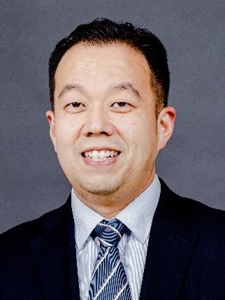

Dr. Minghao ZHAO is Professor & Deputy Director of Center for American Studies at Fudan University. His research focuses on Sino-US relations and international security. He is author of Strategic Restraint: Is New-type Sino-US Relationship Possible and The Belt & Road Initiative and China’s Connectivity-oriented Global Diplomacy. His work has been published in numerous political science and policy journals, including the World Economy and Politics, Chinese Journal of International Politics, International Spectator, and the China Review. He is non-resident Senior Fellow at the Institute of International and Strategic Studies, Peking University and the Center for International Security and Strategy, Tsinghua University.
He is frequently consulted by China government and the policy reports written by him have informed Chinese top leadership. He has contributed policy papers for Center for American Progress, Carnegie Endowment for International Peace, US National Bureau of Asian Research, and Italian Institute of International Affairs among other research institutions. His opinion pieces have been featured in People's Daily, New York Times, Project Syndicate, Nikkei Asian Review, The Diplomat among other media outlets. His views on international affairs have been quoted in Washington Post, Financial Times, Les Echos, BBC, NHK, and other prominent outlets.
He has participated in international research projects, such as Global Trends and China-US Relations, a project co-sponsored by the Atlantic Council and China Institute for International Studies. He has been invited to speak at international conferences, including World Peace Forum (Tsinghua University), Beijing Forum (Peking University), Xiangshan Forum (China Acadamy of Military Science), Global Strategic Review Conference (International Institute for Strategic Studies, UK), Atlantic Dialogue (German Marshall Fund, US), The Rhodes Forum (The Dialogue of Civilizations Research Institute, Russia), Asan Beijing Forum (Asan Institute for Policy Studies, ROK) and the Trilateral Commission conference.
He received a Ph.D. in International Relations, a MA in Diplomatic History, and a BA in Art Studies from Peking University. He also earned a LL.M in International Human Rights Law from a joint program by Lund University, Sweden and Peking University. He has held visiting scholarships in the United States, Italy, Japan, and Taiwan.

赵明昊，复旦大学美国研究中心副主任、教授，博士生导师。入选国家级人才支持计划。研究领域为中美关系、国际安全。专著有《战略克制：新型中美关系的构建》《“一带一路”：互联互通新外交》等。在国内外核心学术刊物发表60余篇论文。兼任北京大学国际战略研究院特约研究员、清华大学战略与安全研究中心客座研究员、亚太安全合作理事会（CSCAP）中国国家委员会委员等学术职务。
他撰写的决策咨询报告获得中央主要领导、中央政治局常委等批示。其研究成果也曾被美国进步中心、卡内基国际和平基金会、美国国家亚洲研究局、意大利国际关系研究院等机构发表。其评论文章见诸《人民日报》《纽约时报》以及“世界报业辛迪加”“日经亚洲评论”“外交学者”等平台。他接受美国《华盛顿邮报》、英国《金融时报》、法国《回声报》、日本放送协会（NHK）等媒体的采访。
他参与诸多国际合作研究项目，如中国国际问题研究院和大西洋理事会共同展开的“全球趋势与中美关系”项目。受邀参加国际会议并发言，如世界和平论坛（清华大学）、北京论坛（北京大学）、香山论坛（中国军事科学院）、全球战略评估会议（英国国际战略研究所）、大西洋对话（德意志马歇尔基金会）、罗德岛论坛（俄罗斯文明对话研究所）、峨山北京论坛（韩国峨山政策研究所）以及三边委员会会议。
他在北京大学先后获得艺术学专业学士/国际关系与对外事务专业学士、中外关系史专业硕士、国际关系专业博士学位，曾赴美国、日本、意大利、台湾等地访学或讲学。

